**EE3CL4 – Lab 2 Report**

**L04 - Group 06 - Tuesday**

**Yiming Chen, 400230266**

**Ruiyi Deng, 400240387**

[cheny466@mcmaster.ca](mailto:cheny466@mcmaster.ca)

[dengr6@mcmaster.ca](mailto:dengr6@mcmaster.ca)

Feb 4th, 2022

Contribution:

Ruiyi Deng takes charge of parts I

Yiming Chen takes charge of parts II

**Objective:**

The objective of this lab is to identify the plant model of a marginal-stable servomotor for subsequent experiments.

**Part I: Time Domain Approach**

We first process the experiment with the proportional gain K at 1 and 2 to observe the nonlinear behavior. Attached below is the measurements from this section.

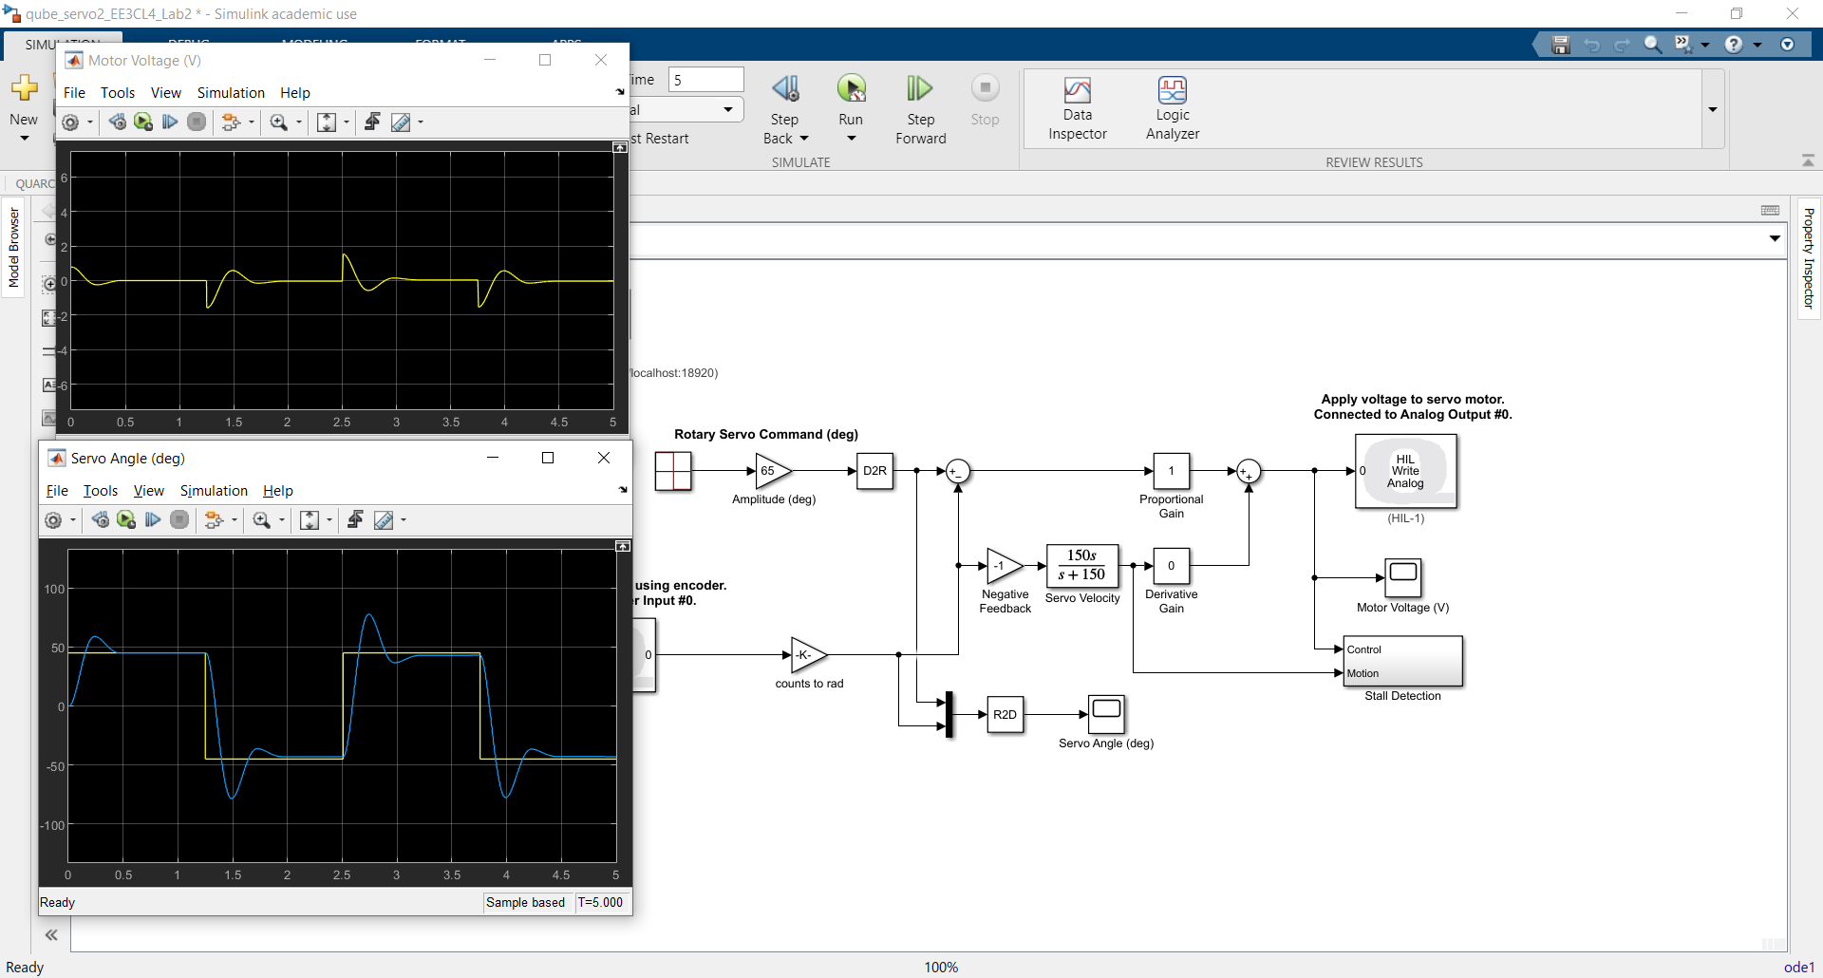

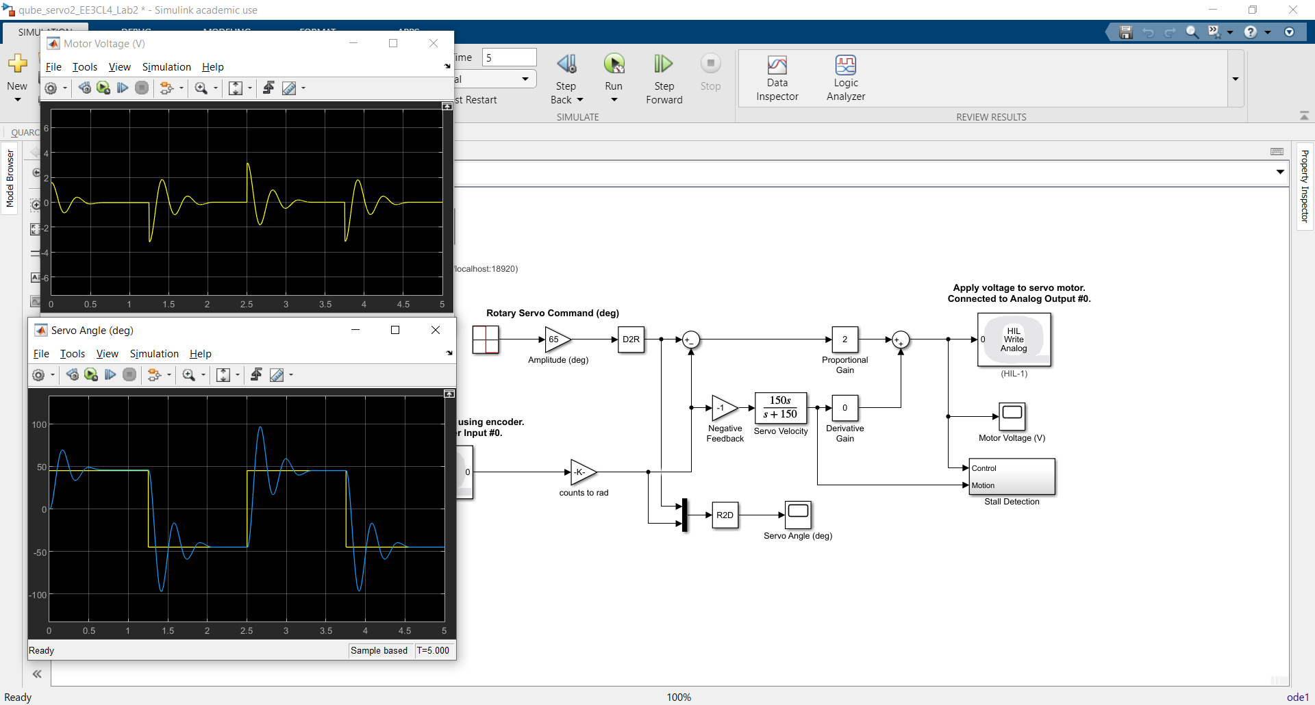

From the reflection on Quanser, the nonlinear behavior diminished with the increasing proportional gain. As a result, the overshoot of the servo motor increased. This can be observed from the peak of the blue lines.

The parameter set for this experiment is 45 degrees for the input square wave amplitude. The switching time can be considered as an edge thus can be neglected.

We used the tool "Peak Finder" from the suggestion of the lab manual to measure the height and time of the first overshoot peak. The start time of the overshoot should be set at the rising edge and the end is where the blue line reached the highest position. The detailed data is shown below with K = 2.

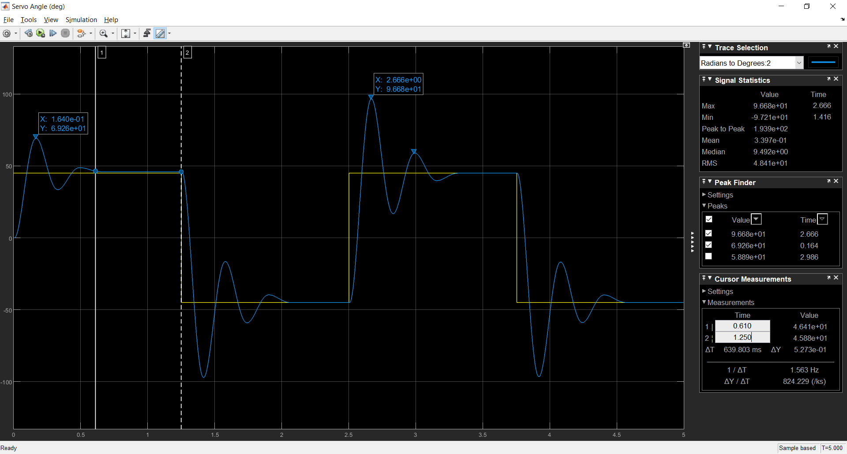 We can find that the time of the first peak occurred was 0.164 second and the first overshoot peak was 69.26 degrees. The calculation of percent overshoot:

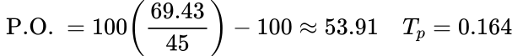

From the calculated *P.O.,* we can then obtain ζ and ωn

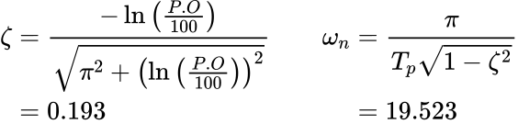

From these two parameters, we can then get *A* and m

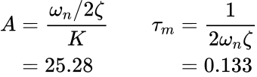

**Part II: Frequency Domain Approach**

In this part we will assume the calculated parameter ζ to be 0.193. From Figure. 3 given in the lab manual that at about proportional gain at 2, we would have -10 dB. This result verified assumption so we chose K = 2 to be the appropriate proportional gain.

Start at 0.5 Hz, and set the signal type to "sine", we begin to do the frequency domain analysis.

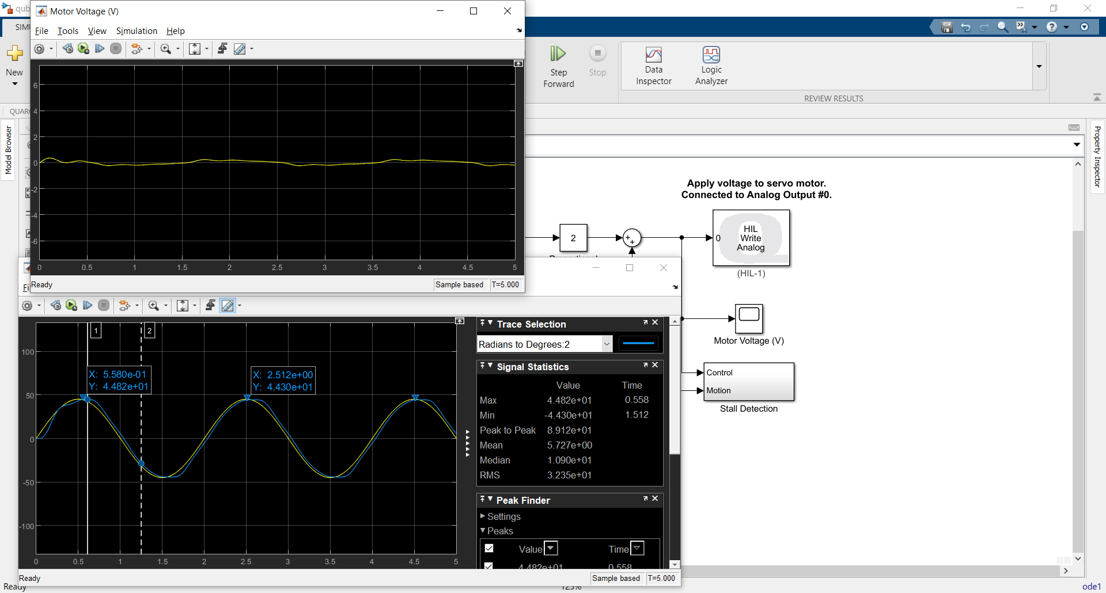

There is small phase delay with the input signal as expected from the bode plot. The non-linear behavior remained but diminished. When the motor changed its direction, the output is not exactly sinusoidal.

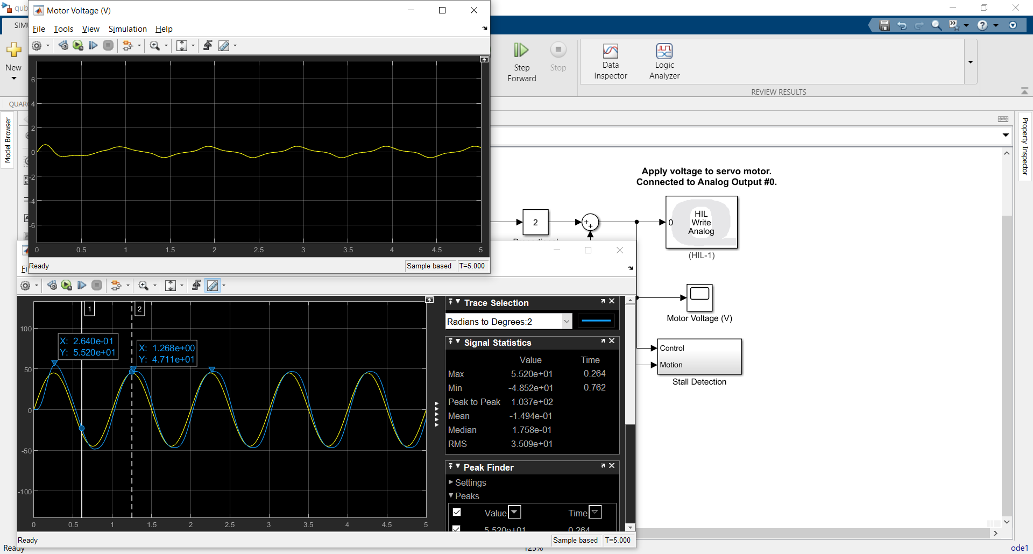

Then we increased the input frequency to 1 Hz, we can find that the gain and the delay of the whole system slightly increased as expected from the bode plot. We still can see some non-linear behavior but it is reduced.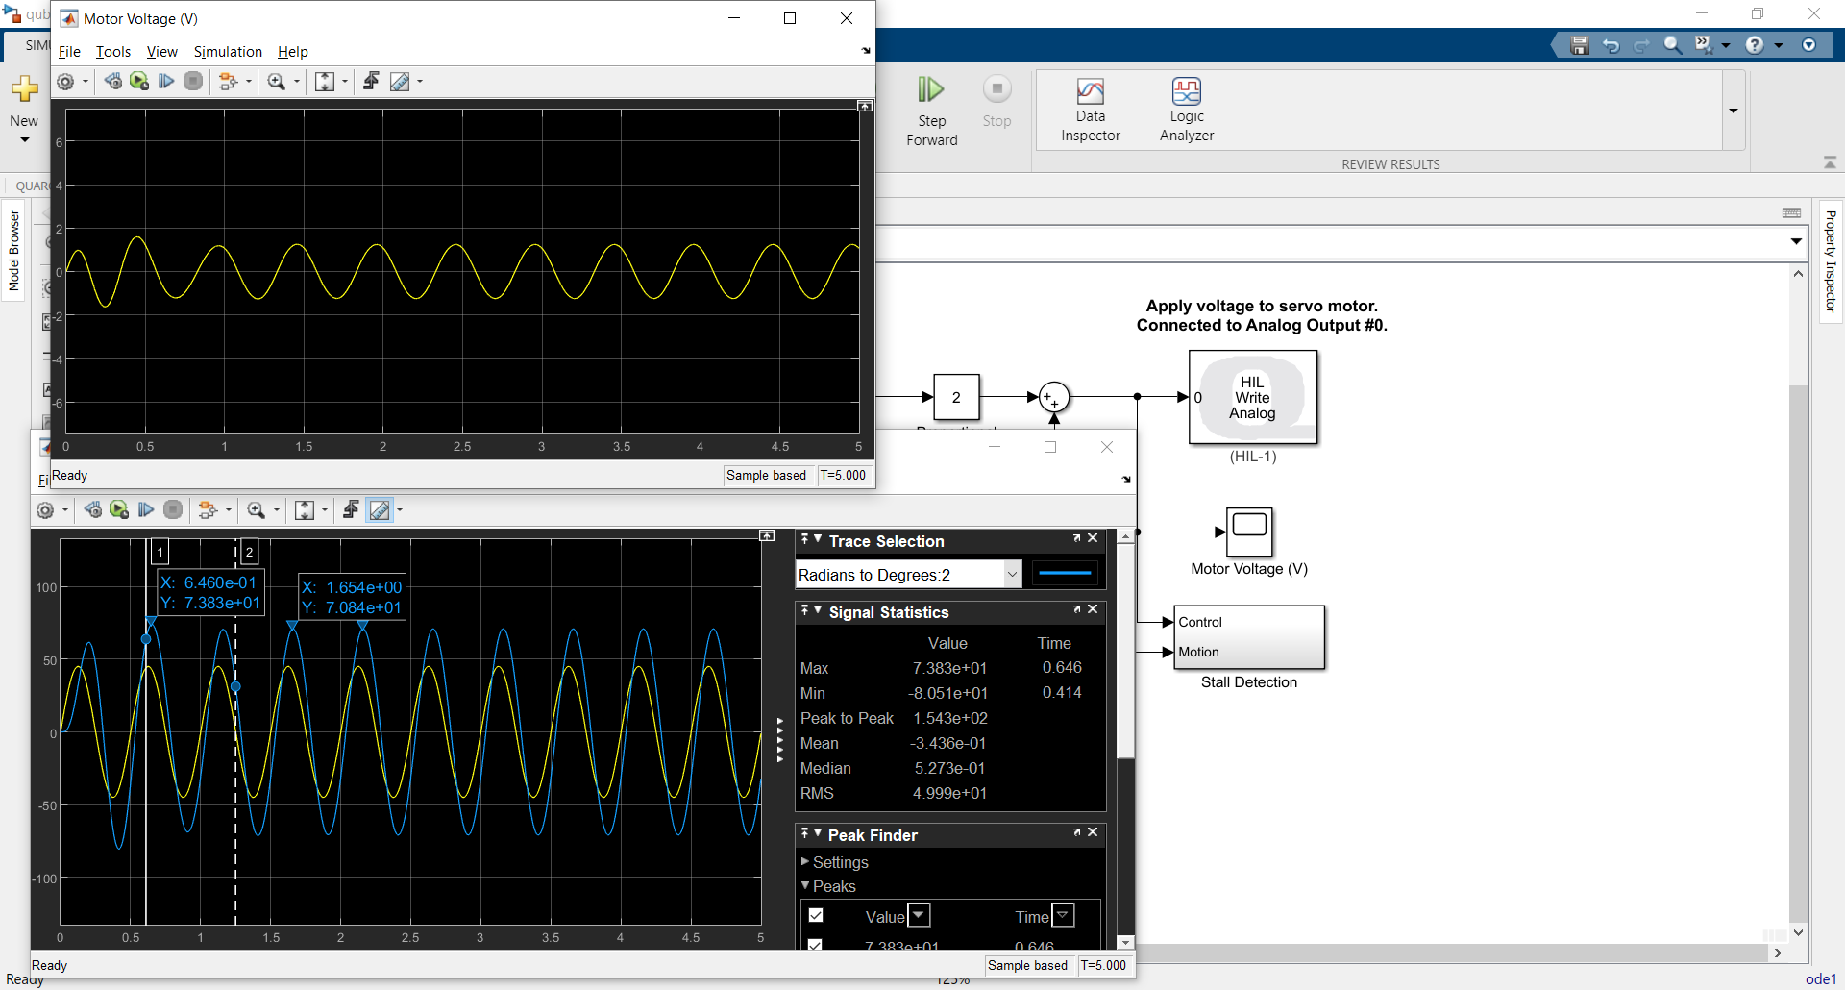

After we set the input frequency to 2 Hz, we noticed that both the delay and the gain was much greater than what we got in 1 Hz, and this matched the bode plot as we are moving right in the plot. Also the non-linear effects can be ignored at this time.

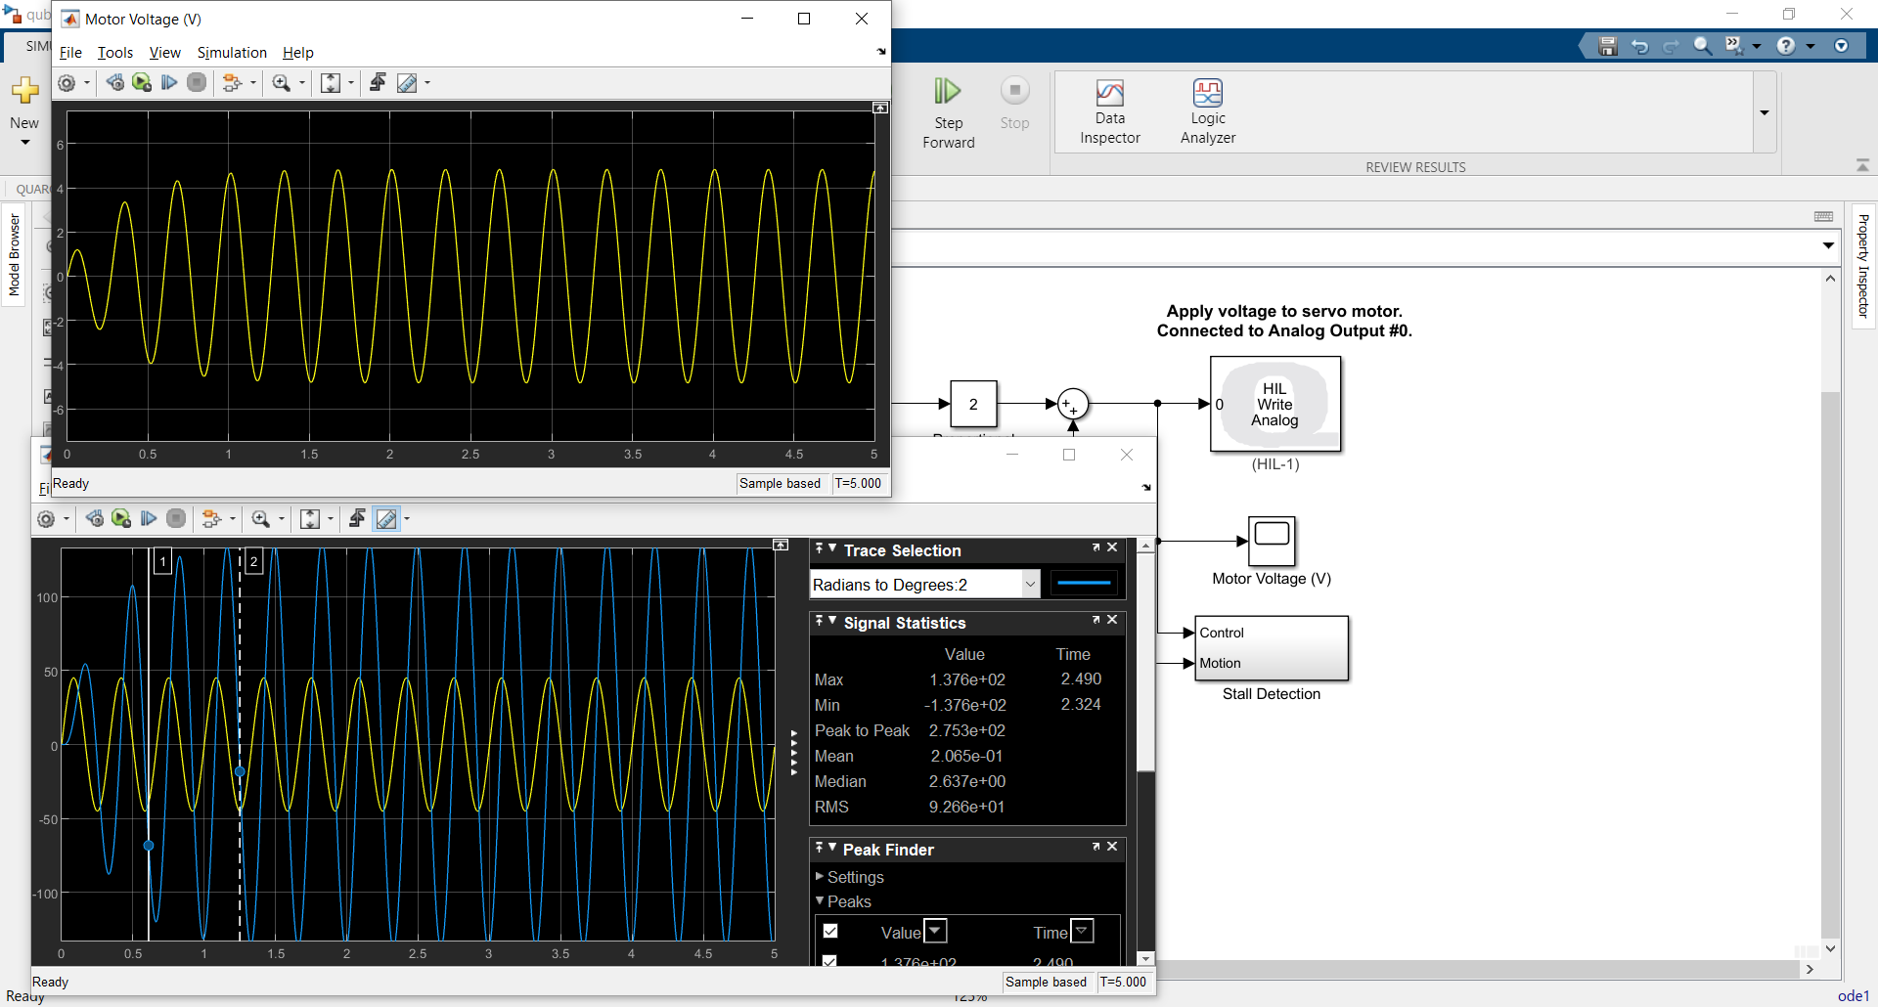

At 3 Hz, we can see that the gain increased greatly, this might because the frequency is corresponded to the peak-around area of the bode magnitude plot. The phase delay is significant now, as we can notice there is a step decrease in the phase in the region of bode phase plot where our frequency is at.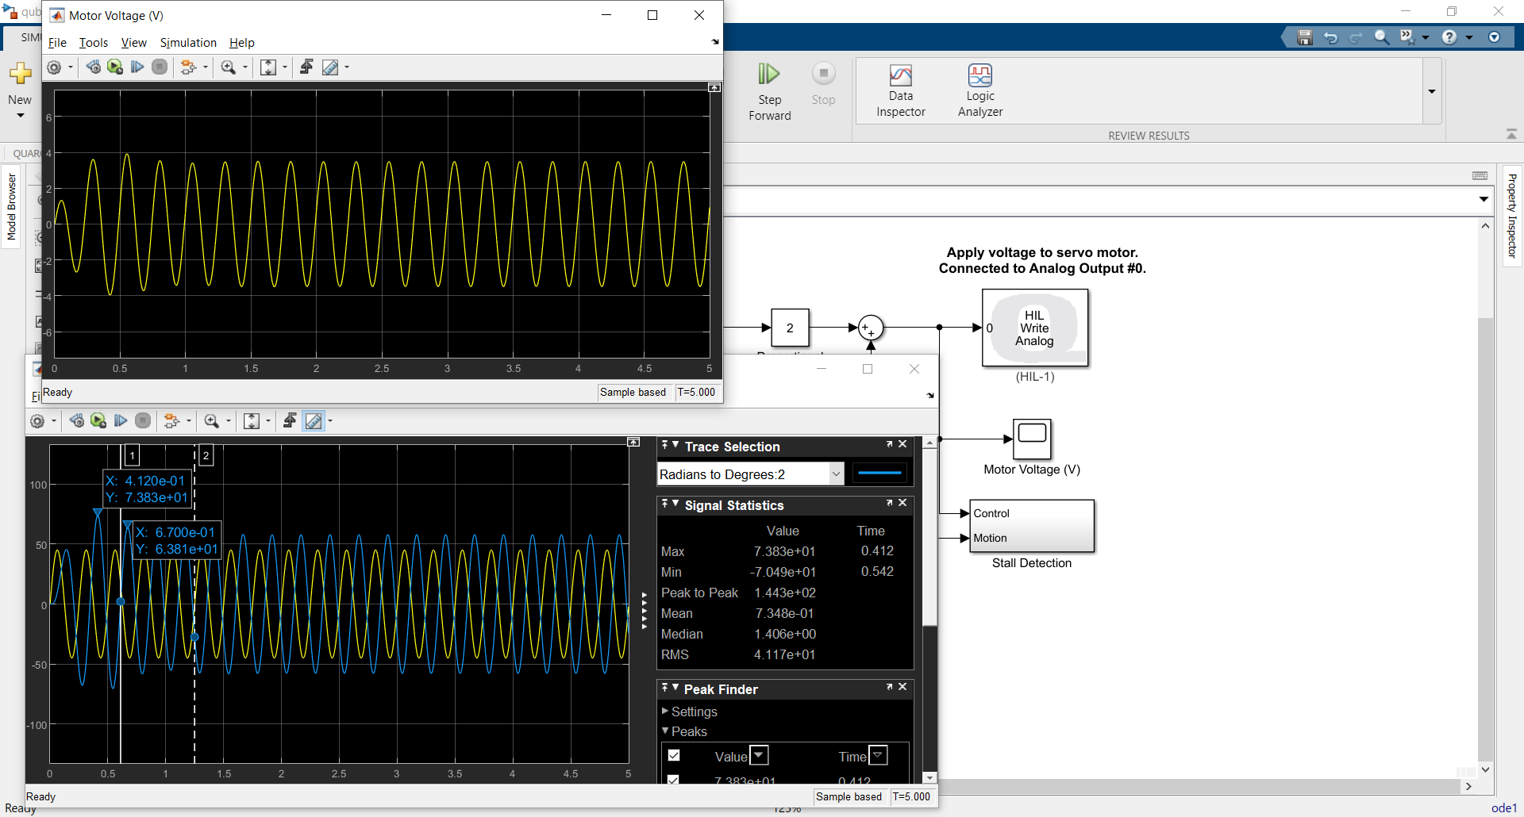

Keeping increasing the input frequency to 4 Hz, the gain starts to decrease as expected in the bode magnitude plot. And the output is also out of phase compare to the input, which is around where the bode phase plot begin to stabilize around -180 degrees.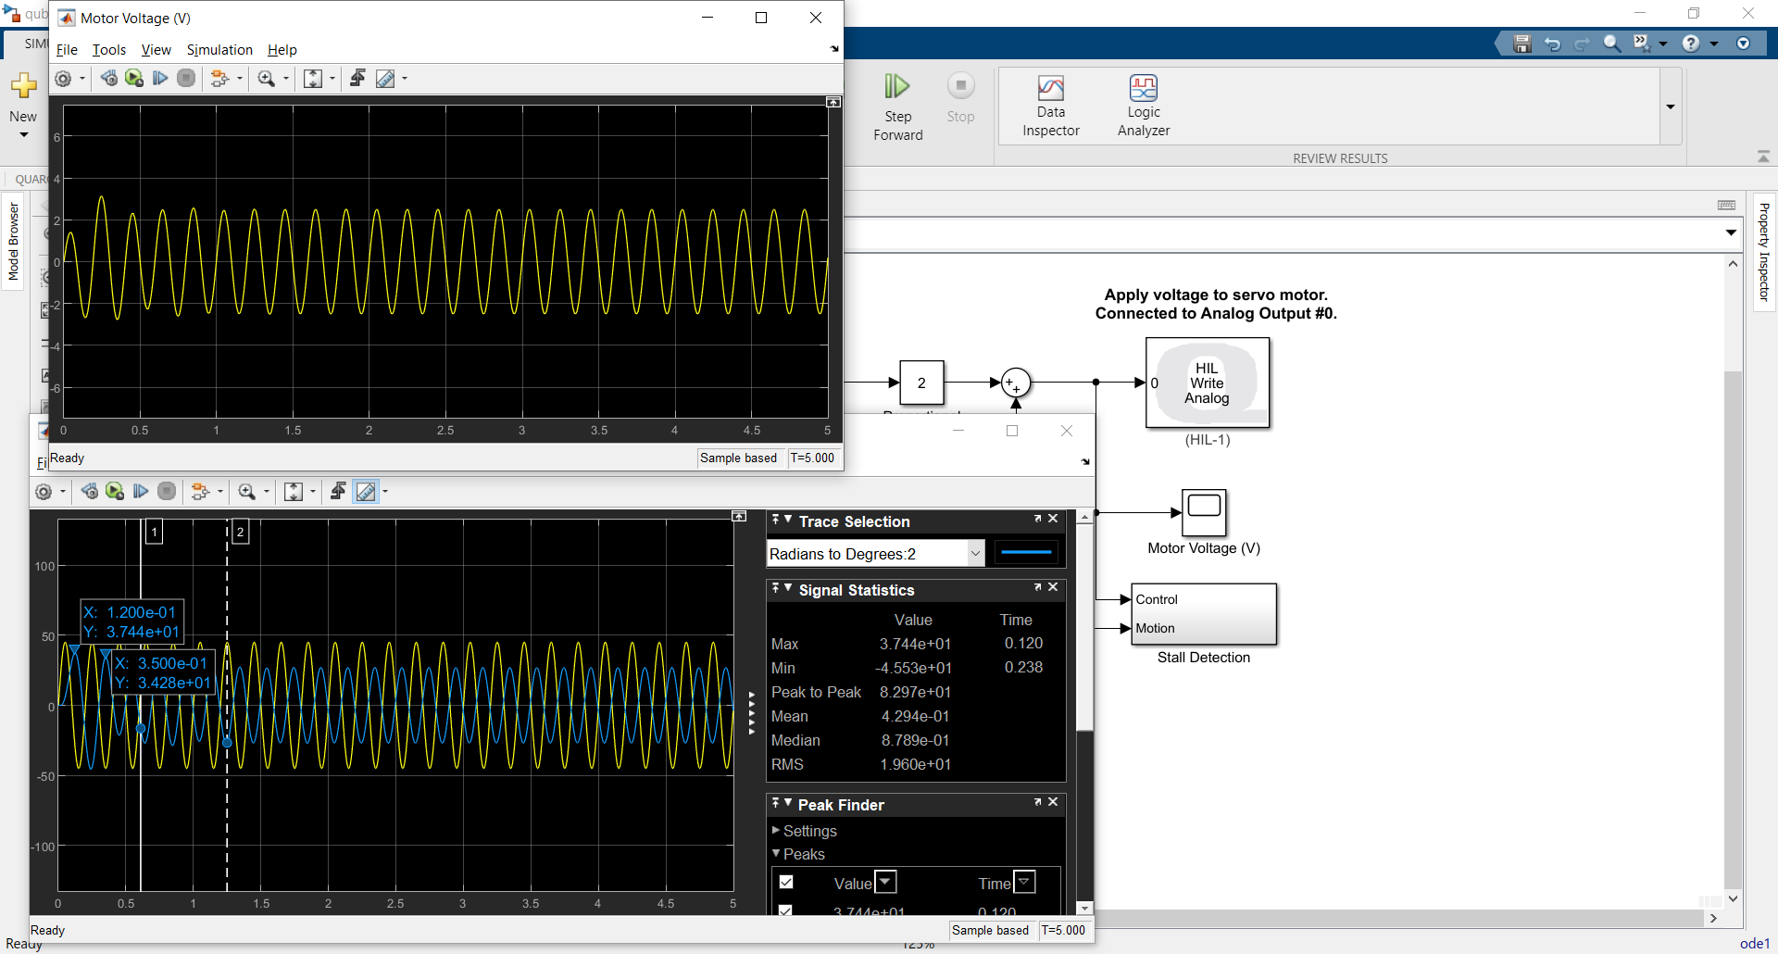

At 5 Hz, the gain is still decreasing, falling below 0 dB and attenuating the output signal. This means the frequency is in a region where the bode magnitude plot is decreasing in a stable rate. The phase delay is same as what we got in 4 Hz.

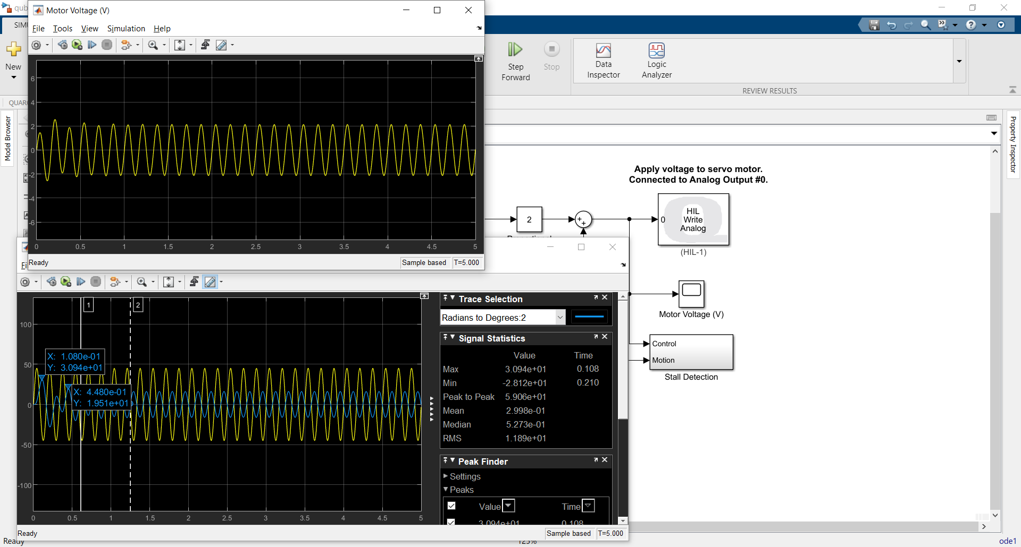

Increase the input to 6 Hz, the gain decreases while the phase delay remains the same as what we got in 5 Hz. This matches our expectation from the bode plot.

In general, our observation of the magnitude and phase of the output signal matches our expectation based on the bode plots from the lab document. We have no magnitude gain from starting point and it begins to increase until it reaches a peak value and then begins to decrease. We have no phase delay from starting point and it begins to increase until it stabilizes around 180 degrees.

The strategy we used for this section is binary search. We observe there is a decreasing tendency between 3 Hz and 4 Hz, so we started at 3 Hz and finally, we got the peak amplitude at 3.04 Hz with 138.2 degrees. The result is shown below.

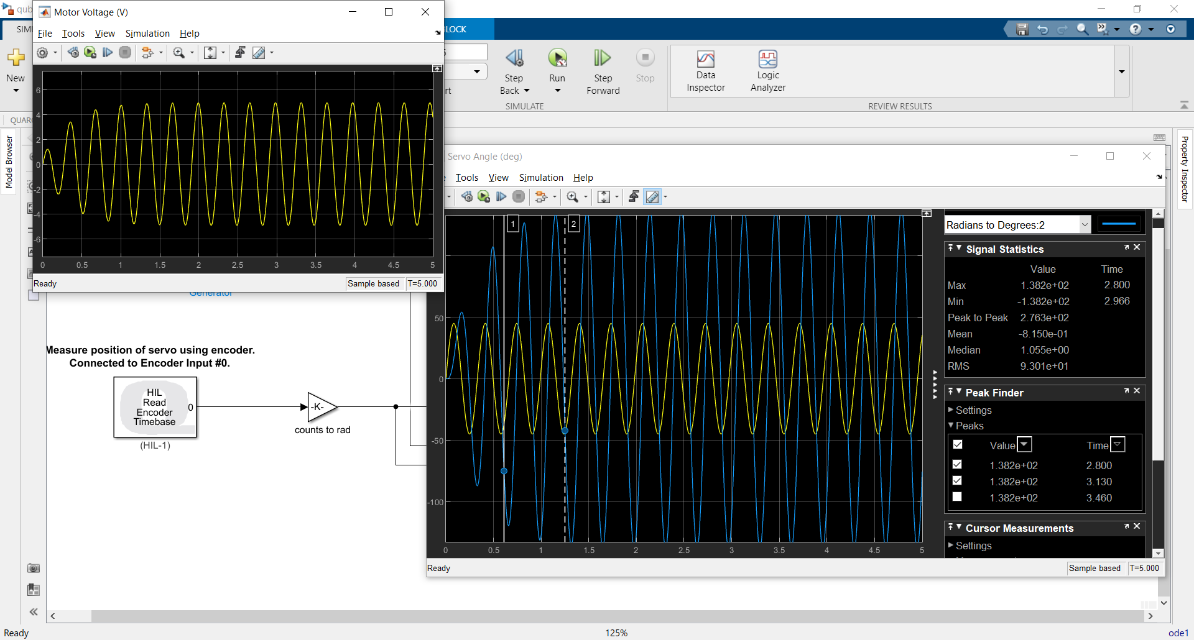

Apply these recorded data and then we can determine the value of peak gain *Mp*and peak frequency ωp:

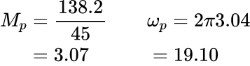

From these parameters we can then calculate ζ and ωn accordingly:

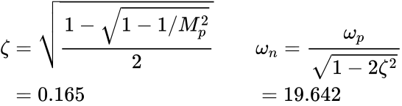

From these two parameters, we can then get *A* and m:

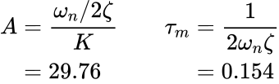

**Comparison and Discussion:**

The value of *A* obtained through time domain identification is 25.28 and m is 0.133. While through frequency domain identification *A* is 29.76 and m is 0.154.

This slight difference may come from the non-linear effects of the simulation model and the pole quantity mismatch. In general, these two simulation results are relatively close.

**How to improve accuracy of the estimation of model parameters:**

We can calculate our values for *A* and m in one method and substitute them back to another method to get the theoretical value which we should measure. If we detect any significant difference between the measured value and the theoretical value which we calculated earlier, this might indicate that there is something wrong with our calculation or measurement. Another method to improve the accuracy is to repeat the analysis after several measurement or with different proportional gain value K.